New Plymouth Pony Club (NPPC) Grounds Use Application & Rules 2022/2023

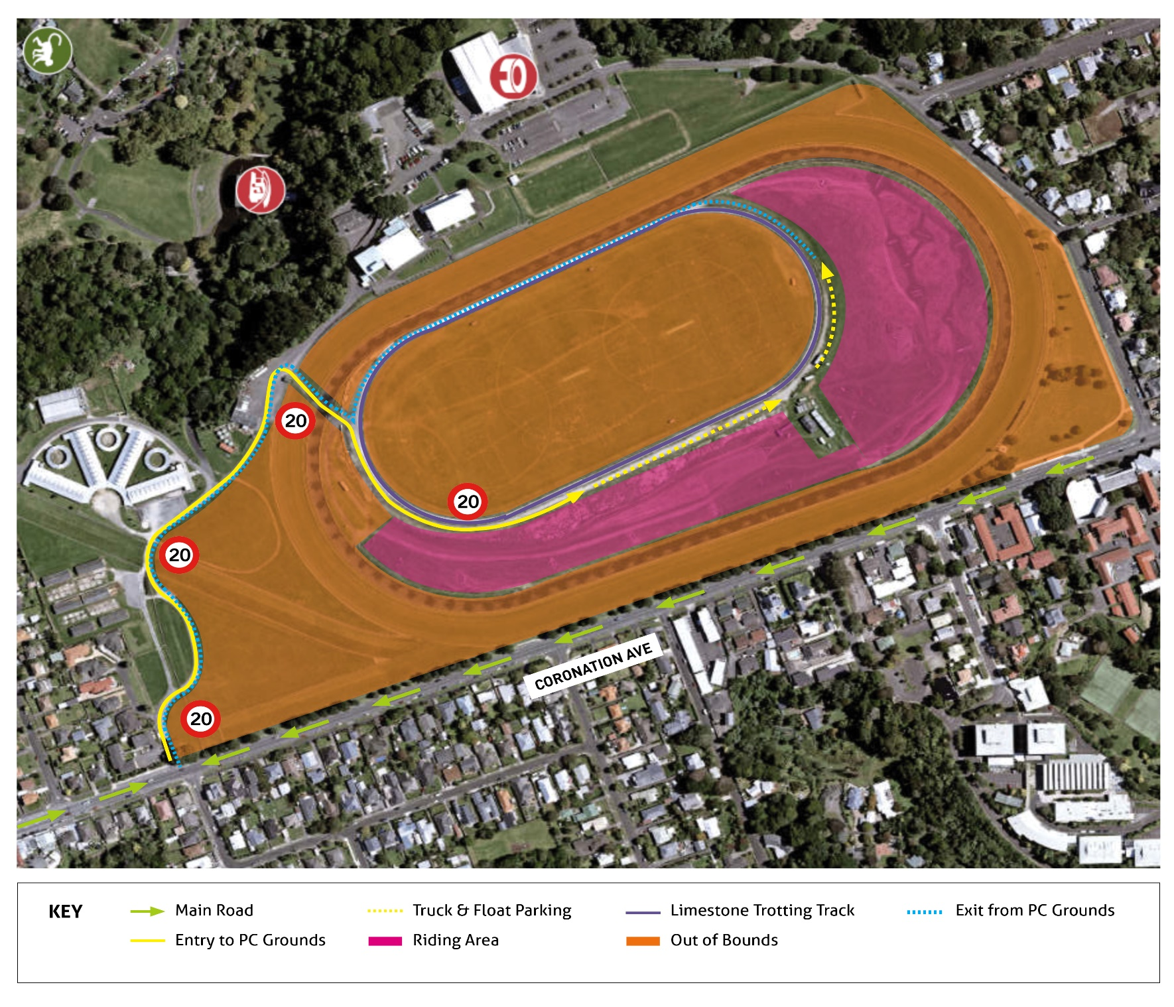

Welcome!
NPPC, with the support of New Plymouth Raceway (NPR), are delighted to welcome you to the NPPC grounds and the limestone trotting track at Pukekura Raceway, New Plymouth. You will enjoy the short travel time to this central location. You and your horse will benefit from-
- the cross-country area and jumps;
- the show-jumps; (both areas in pink)
- wet weather fitness/interval training opportunities on the limestone trotting track; (in purple) and
- general exposure to large green space areas.
It is important that all users access ONLY the permitted areas and DO NOT RIDE ON THE COURSE PROPER or ON THE ALL-WEATHER SAND TRACK. That will jeopardise access for everybody and ensure your permission is immediately withdrawn, with no refund of subscription. We are confident that all riders will respect this special opportunity and we rely on your honesty to use this area according to these Rules.
For the subscription year-1st August 2022 to 31st July 2023, the ground fee to Non-NPPC members will be: $120.00. This will allow access for the main Sub Holder and one family member on each visit. Additional family members will be $30.00 per adult or child. Any users under 18 will have to be accompanied by an Adult. If you bring a riding friend with you on occasion-
- that person must pay $10.00 to the NPPC account stated below; and
- shall be bound by the Rules below (any breach of same will jeopardise the sub-holders use-rights)
Please contact Kelly Megchelse taranakiponyclub@gmail.com with any queries.

Your Grounds Use Subscription must be paid to the NPPC bank account-
TSB 15-3957-0043422-03. Please insert-
- your name in the Particulars field: and
- GroundsUse in the Reference field.
You will need to request to join the NPPC facebook page to check access for your visits.

Application for NPPC (Non-Member) Grounds Use Agreement: 2022/2023
(to be considered by NPPC Committee)

Sub-Holder Name: ……………………………………………………………………………
Address: ……………………………………………………………………………………….
Home Phone: ………………………… Mobile number: …………………………………
Email address: ……………………………………………Date of Application ……………
Number plate of truck or tow vehicle/s …………………………………………………….

Fee Payable is $120.00 per annum for one Sub Holder & one family member. Further family members are $30 per person. $10.00 per visit for the occasional riding friend you may bring along.

NP Pony Club Rules for Trotting Track and Grounds Use:
- Due to racehorse training, there will be no access before 10.00am Monday to Friday, 9.00am Saturday and Sunday, and 10.00am on Public Holidays.
- Users can access ONLY the permitted areas and MUST NOT ride or take vehicles on the COURSE PROPER, the ALL-WEATHER SAND TRACK or the SPORTS PITCHES Any breach will jeopardise access for everybody and ensure your permission is immediately withdrawn, with no refund of subscription. In addition, a $1000.00 fine will be imposed on anyone breaking this rule, or on the parent or guardian of the person doing so, if they are under 18 years of age.
- Access is across THE GAP-either via the usual gate, if unlocked, or through the 2m high, double gate, cage area.
- Race days and major events such as Relay for Life, Americana and WOMAD also mean horses and riders are excluded on these days. Users are to check the NPPC Facebook page for what’s on before arriving. You may be asked to leave if there is a conflict or wait until the grounds are free before using. Please check before starting your trip to avoid being disappointed.
- Pony club rallies and events organised or sanctioned by NPPC have priority over private users. A full calendar is available on the New Plymouth Pony Club Website.
- You can only use the show-jumps that are already in place. Do not help yourself to any other jump equipment.
- Approved helmets must be worn when mounted, and back protectors if using any cross-country jumps.
- Please ensure you shut the gates onto the track when you enter and leave.
- All riders and horses enter and use the grounds and trotting track at their own risk.
- All horses must always be under full control.
- All equipment must be used in a responsible manner with the welfare of the horse/pony in mind and not in such a manner as is likely to cause damage to the equipment.
- You must notify any damage by phoning the NPPC President (Rob Sullivan 021 270 8899) and, depending on what is damaged, you may be liable for the cost associated with repair or replacement.
- All horse manure from the trotting track and parking areas must be picked up and taken away with you. Manure on grass areas is to be spread around by kicking it out.
- Please take your rubbish away with you.
- Please park your trucks and floats alongside the tin fence on the limestone access road, not on the grass.
- Riders aged under 18 must be supervised by a parent or guardian aged over 18 years of age.
- Well behaved dogs under voice command are permitted access. The owner/carer may be asked to leave or tie the dog up, if necessary.
- Only Sub-Holders, named family members listed below, and an occasional friend upon payment of the fee, are permitted to ride on the grounds under this subscription. Breach of this can lead to cancellation and again, no refund.
Upon acceptance of this Application by NPPC, I/we agree that-
- I/we are bound by the Rules set out above;
- Failure to abide by the Rules will result in the cancellation of this agreement and forfeiture of any remaining Sub Fee;
- The NPPC Committee reserves the right to add to or to change the rules as it sees fit;
- Applications from parents, guardians, and riders named below will be considered on an individual basis (and child if under 18.)
Signatures of all riders (or parent/guardian if rider is under 18) is required signifying agreement to these terms.

Rider’s Name | Signature

